U23HSTC02 RESEARCH METHODOLOGY

UNIT-III | Research Methods and Data Analysis | Periods: 6
Introduction to Experimental Research, Developing Hypotheses: Basic Approach. Data Collection Methods: Sampling and Surveys, Basics of Data Analysis: Numerical and Graphical Analysis, Introduction to Inferential Statistics.

I. Introduction to Experimental Research
A. Definition and Purpose
1. Investigating cause-and-effect relationships
2. Manipulation of independent variables
3. Measurement of dependent variables
4. Control of extraneous variables
B. Key Terms
1. Independent Variable (IV), Dependent Variable (DV), Extraneous Variable, Confounding Variable
2. Control Group, Experimental Group
C. Basic Experimental Designs
D. Strengths and Weaknesses of Experimental Research
II. Developing Hypotheses: Basic Approach
A. Definition of Hypothesis
B. Characteristics of a Good Hypothesis
C. Types of Hypotheses
1. Null Hypothesis (H0​)
2. Alternative Hypothesis (H1​ or Ha​)
3. Directional vs. Non-directional Hypotheses
D. Formulating Hypotheses from Research Questions/Objectives
E. Role of Hypotheses in the Research Process
III. Data Collection Methods: Sampling and Surveys
A. Introduction to Data Collection
Primary vs. Secondary Data
B. Sampling
1. Definition and Purpose
2. Population vs. Sample
3. Sampling Frame
4. Types of Sampling Techniques
a. Probability Sampling: Simple Random, Systematic, Stratified, Cluster
b. Non-Probability Sampling: Convenience, Purposive, Quota, Snowball
5. Determining Sample Size (brief conceptual understanding, not calculation)
C. Surveys
IV. Basics of Data Analysis: Numerical and Graphical Analysis
A. Introduction to Data Analysis
B. Numerical Analysis
C. Graphical Analysis
V. Introduction to Inferential Statistics
A. Purpose of Inferential Statistics
B. Key Concepts
C. Common Statistical Tests
D. Role of Statistical Software

I. INTRODUCTION TO EXPERIMENTAL RESEARCH
A. DEFINITION
Experimental research is a systematic and scientific approach to research where the researcher manipulates one or more variables (independent variables) and measures their effect on one or more other variables (dependent variables), while controlling for other extraneous variables. Its primary purpose is to establish cause-and-effect relationships between variables.
Characteristics:
- Investigating Cause-and-Effect Relationships: This is the core purpose of experimental research. Unlike correlational studies that only identify associations, experiments aim to determine if a change in one variable directly causes a change in another. For example, does a new teaching method (cause) lead to higher test scores (effect)?
- Manipulation of Independent Variables: The independent variable (IV) is the factor that the researcher intentionally changes or varies. This manipulation creates different conditions or levels of the IV to observe their impact. For instance, in a study on fertilizer's effect on plant growth, the independent variable would be the amount of fertilizer applied (e.g., 0g, 10g, 20g).
- Measurement of Dependent Variables: The dependent variable (DV) is the outcome or effect that is measured. It's the variable that is expected to change in response to the manipulation of the independent variable. Using the fertilizer example, the dependent variable would be plant height or biomass.
- Control of Extraneous Variables: Extraneous variables (also known as confounding variables) are any variables other than the independent variable that could potentially affect the dependent variable. Experimental research strives to control these variables to ensure that any observed changes in the dependent variable are indeed due to the independent variable and not other factors. This can be achieved through various methods such as randomization, blinding, and standardized procedures. For example, in a plant growth experiment, extraneous variables might include sunlight exposure, water given, and soil type.

B. KEY TERMS IN RESEARCH
Hypothesis: A testable statement predicting a relationship between variables.
- Example 1: "Plants given fertilizer X will grow taller than plants given no fertilizer."
- Example 2: "Children who attend preschool will demonstrate better social skills in kindergarten than children who do not attend preschool."
Independent Variable (IV): The variable manipulated by the researcher.
- Example 1: In a study on the effect of caffeine on alertness, the amount of caffeine administered (e.g., 0mg, 50mg, 100mg).
- Example 2: In an experiment testing different teaching methods, the type of teaching method (e.g., traditional lecture, active learning).
Dependent Variable (DV): The variable measured by the researcher; the outcome.
- Example 1: In the caffeine study, the score on an alertness test or reaction time.
- Example 2: In the teaching methods experiment, the students' scores on a post-lesson quiz.
Experimental Group: The group that receives the treatment or manipulation of the independent variable.
- Example 1: In a drug trial, the group that receives the actual new medication.
- Example 2: In a study on the effectiveness of a new exercise program, the group that participates in the new exercise program.
Control Group: The group that does not receive the treatment, used for comparison.
- Example 1: In the drug trial, the group that receives a placebo or standard treatment.
- Example 2: In the exercise program study, the group that continues with their regular routine or no structured exercise.
Random Assignment: The process of assigning participants to experimental or control groups randomly to ensure groups are equivalent at the start of the study, minimizing pre-existing differences.
- Example 1: Flipping a coin for each participant to decide if they go into the "new diet" group or the "control diet" group.
- Example 2: Using a random number generator to assign students to either a "computer-based learning" group or a "textbook-based learning" group.
Extraneous Variable (Confounding Variable): A variable other than the IV that could affect the DV, and thus needs to be controlled.
- Example 1: In a study comparing two teaching methods, the prior academic performance of the students in each group could be an extraneous variable if not controlled.
- Example 2: In a study on the effect of a new fertilizer on plant growth, the amount of sunlight each plant receives or the type of soil used for each plant.
Blinding: A technique where participants (single-blind) or both participants and researchers (double-blind) are unaware of who is in the experimental or control group to prevent bias.
- Example 1 (Single-blind): Participants in a taste test are not told whether they are tasting the regular soda or the new, sugar-free version.
- Example 2 (Double-blind): In a clinical drug trial, neither the patients nor the doctors administering the drug know whether the patient is receiving the active drug or a placebo.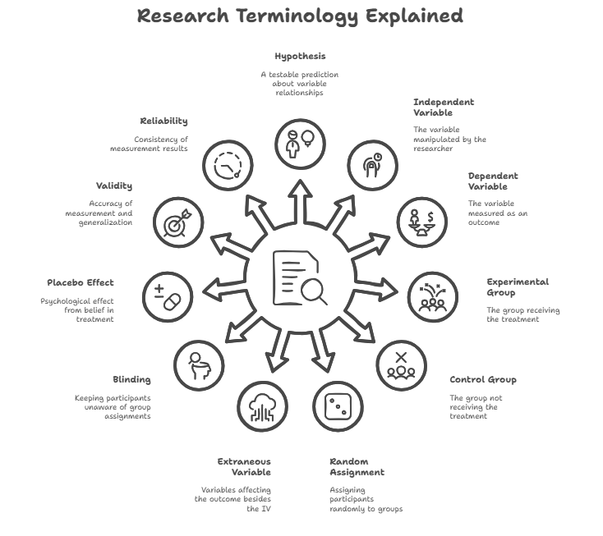
Placebo Effect: A psychological or physiological effect experienced by participants in a control group due to their belief in receiving a treatment, even if it's inert.
- Example 1: A patient feeling less pain after taking a sugar pill, believing it to be a powerful painkiller.
- Example 2: An athlete performing better in a race after being given a "performance-enhancing" drink, even though it was just water.
Validity: The extent to which a study accurately measures what it intends to measure (internal validity) and the extent to which its findings can be generalized to other populations or settings (external validity).
- Example 1 (Internal Validity): A study on the effect of a new medication accurately concludes that the medication caused the observed improvement in symptoms because all other variables were controlled.
- Example 2 (External Validity): A study conducted on college students in a lab setting might have low external validity if its findings cannot be applied to older adults in a real-world job environment.
Reliability: The consistency of a measure; whether it produces similar results under similar conditions.
- Example 1: A bathroom scale is reliable if you weigh yourself five times in a row and it gives you roughly the same weight each time.
- Example 2: A personality questionnaire is reliable if a person takes it today and then again next week, and their results for each personality trait are consistent.

C. BASIC EXPERIMENTAL DESIGNS
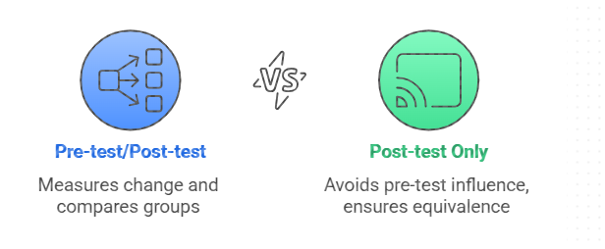
Experimental designs are frameworks that researchers use to structure their experiments to ensure valid and reliable results. Some basic designs include:
- Pre-test/Post-test Control Group Design: Participants are randomly assigned to either an experimental group or a control group. Both groups are given a pre-test, the experimental group receives the treatment, and then both groups are given a post-test. This allows for the measurement of change within each group and comparison between groups.
- Post-test Only Control Group Design: Similar to the pre-test/post-test design, but without the initial pre-test. This design is useful when a pre-test might influence the results or is not feasible. Random assignment is crucial to ensure initial equivalence.
- Factorial Design: This design involves two or more independent variables (factors) simultaneously. It allows researchers to examine the main effects of each independent variable and also their interaction effects (how the effect of one IV changes across levels of another IV). For example, a study could investigate the effects of both a new teaching method and class size on student performance.
D. Strengths and Weaknesses of Experimental Research
Strengths:
- Establishes Cause-and-Effect: This is the most significant advantage. Experiments are the strongest method for determining causal relationships due to the manipulation of independent variables (IVs) and the control of extraneous variables.
- High Internal Validity: When properly conducted, experimental research has high internal validity, meaning that the observed effects are genuinely due to the independent variable and not other factors.
- Replicability: Experiments are often designed with clear procedures, making them easier to replicate by other researchers to verify findings and ensure reliability.
- Control: Researchers have a high degree of control over variables, allowing for precise measurement and isolation of effects.
Weaknesses:
- Artificiality (Low External Validity): The highly controlled environment of an experiment can sometimes make it artificial, limiting the generalizability of findings to real-world settings.
- Ethical Concerns: Some research questions cannot be addressed experimentally due to ethical considerations (e.g., studying the effects of child abuse).
- Time-Consuming and Expensive: Designing and conducting well-controlled experiments can be time-consuming and resource-intensive.
- Practical Constraints: It's not always feasible or practical to manipulate certain variables (e.g., a person's gender, socioeconomic status).
- Participant Bias: Participants might behave differently if they know they are being observed or are part of an experiment (Hawthorne effect).
- Experimenter Bias: The researcher's expectations can unintentionally influence the results. Blinding techniques can help mitigate this.

HYPOTHESIS
A hypothesis (plural: hypotheses) is a testable statement that proposes a relationship between two or more variables. It's an educated guess or a tentative explanation for an observed phenomenon that can be supported or refuted through scientific investigation. In the context of experimental research, a hypothesis typically predicts how the manipulation of an independent variable will affect a dependent variable.

A. Definition of Hypothesis
A hypothesis is a tentative statement showing the relationship between two or more variables, the reliability and validity of which is to be tested and verified. It expresses the nature and degree of relationship between variables.
Hypotheses are fundamentally:
- Assumptions
- Tentative statements
- Propositions
- Answering the questions
- Proposed solutions to a problem
- Statements which are to be tested
- To be accepted or rejected based on evidence
- To be verified empirically on the basis of sample data

B. Characteristics of a Good Hypothesis
A well-formulated hypothesis is crucial for guiding research. It should possess several key characteristics:
- It should be related to a body of theory: A good hypothesis is usually grounded in existing scientific theories, previous research findings, or careful observations, rather than just a random guess.
- It should be clear and precise: It must be stated simply and directly, avoiding ambiguity or vague language. The variables and the predicted relationship should be easily understandable.
- It should be capable of verification/testable: It must be possible to collect data that will either support or refute the hypothesis. If a hypothesis cannot be empirically tested, it's not a scientific hypothesis. This also implies it should be capable of being tested.
- It should be simple and specific: It should clearly define the variables involved and the expected nature of their relationship. General statements are difficult to test effectively.
- Measurable: The variables in the hypothesis must be quantifiable or observable in some way. If you can't measure it, you can't test it. (Implicit in 'capable of verification')
- Relevant: It should be relevant to the research question and contribute to the existing body of knowledge in the field. (Implicit in 'related to a body of theory')

Concepts for Hypothesis Formulation:
- Variables:
  - Clearly identify your independent (predictor) and dependent (outcome) variables.
  - Ensure these variables are measurable.
- Relationships:
  - Hypotheses explore the relationships between variables.
  - These relationships can be positive, negative, or non-directional.
- Testability:
  - A good hypothesis is testable through empirical research.
Words to Use When Formulating Hypotheses:
- Indicating a Positive Relationship: "Increases", "Enhances", "Improves", "Positively influences", "Is positively associated with", "Leads to higher"
- Indicating a Negative Relationship: "Decreases", "Reduces", "Negatively influences", "Is negatively associated with", "Leads to lower"
- Indicating a Relationship (General): "Affects", "Influences", "Is related to", "Impacts"
- Words for Strength/Moderation: "Moderates", "Strengthens", "Weakens", "Amplifies"

C. Types of Hypotheses
Different types of hypotheses serve distinct purposes in research:
- Null Hypothesis (H0​): The null hypothesis is a hypothesis which points out there is no difference between two populations in respect of same property, or no effect, or no relationship between the variables being studied. It assumes that any observed differences or relationships are due to random chance. Researchers typically aim to gather evidence to reject the null hypothesis.
  - Rule 2 & 3: The null hypothesis should contain a statement of equality (=) and is the hypothesis that is tested.
  - \
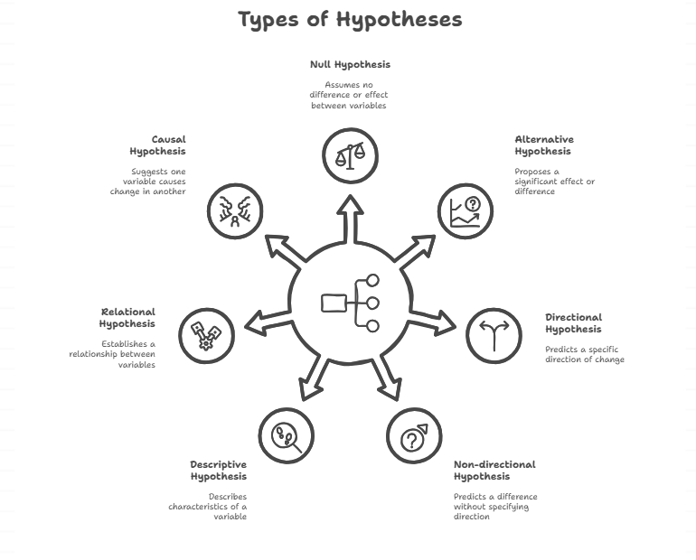
  - Example 1: H0​: There is no significant difference in the average test scores of students who receive daily tutoring and those who do not.
  - Example 2: H0​: Consuming caffeine has no effect on a person's reaction time.
- Alternative Hypothesis (H1​ or Ha​): When we reject the null hypothesis, we accept another hypothesis known as the alternative hypothesis. It is the statement that contradicts the null hypothesis, proposing that there is a significant effect, difference, or relationship between the variables. This is often the researcher's prediction or the hypothesis they are trying to support.
  - Rule 1 & 2: What we hope or expect to be able to conclude as a result of the test usually should be placed in the alternative hypothesis, and it contains a > or < than sign (for directional) or = (for non-directional).
  - Rule 4: The null and alternate hypothesis are complementary.
  - Example 1: H1​: Students who receive daily tutoring will have significantly higher average test scores than students who do not.
  - Example 2: H1​: Consuming caffeine will significantly decrease a person's reaction time.
- Directional vs. Non-directional Hypotheses:
  - Directional Hypothesis: A directional hypothesis specifies the expected direction of the relationship or difference between variables. It indicates whether one variable will be greater than, less than, increase, or decrease in relation to another. These are used when there's a strong theoretical or empirical basis to predict a specific outcome.
    - Example 1: "Students who use the new study app for 30 minutes a day will achieve higher scores on their biology exam than students who do not use the app." (Predicts higher scores)
    - Example 2: "Increased exposure to sunlight will decrease the incidence of seasonal affective disorder." (Predicts a decrease)
  - Non-directional Hypothesis: It is a type of alternative hypothesis used in statistical significance testing. A non-directional hypothesis (also known as a two-tailed hypothesis) states that there will be a relationship or difference between variables, but it does not specify the direction of that relationship or difference. These are used when previous research is inconclusive, or when the researcher is exploring a new area and doesn't have a strong basis to predict a specific direction.
    - Example 1: "There will be a difference in the test scores of students who use
    - the new study app and those who do not use the app." (Does not specify higher or lower)
    - Example 2: "There will be an effect of caffeine consumption on reaction time." (Does not specify faster or slower reaction time)
- Descriptive Hypothesis: Describing the characteristics of a variable (may be an object, person, organization, event, and situation). It describes the characteristics of a variable.
  - Example: Employment opportunity of commerce graduates is more than the arts students.
- Relational Hypothesis: Establishes relationship between two or more variables. It may be positive, negative or nil relationship.
  - Example: High income leads to high savings.
- Causal Hypothesis: The change in one variable leads to change in another variable, i.e., Dependent and independent variables, one variable is a cause and the other one is the effect.
  - (Note: This is a specific type of relational hypothesis where causality is implied.)
- Statistical Hypothesis: Association or difference between two or more variables are hypothesized. These are formulated so they can be tested using statistical methods.
  - (Note: Null and Alternative Hypotheses are forms of statistical hypotheses.)

D. Formulating Hypotheses from Research Questions/Objectives
Hypotheses are typically derived directly from the research question or objectives. The process involves transforming a broad question into a specific, testable statement.
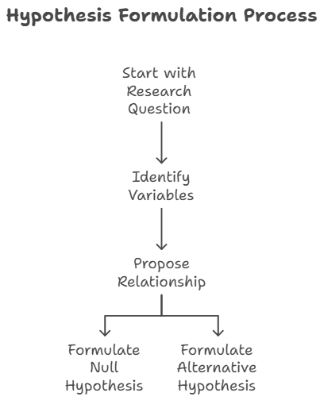
- Step 1: Start with a Research Question/Objective: Identify what you want to know or what problem you want to solve.
  - Research Question: Does a new mindfulness program reduce stress levels in university students?
- Step 2: Identify the Independent and Dependent Variables:
  - IV: New mindfulness program (presence vs. absence)
  - DV: Stress levels
- Step 3: Propose a Relationship: Based on existing literature, theory, or logical reasoning, predict how the IV might influence the DV.
  - Initial thought: Mindfulness might lower stress.
- Step 4: Formulate the Null Hypothesis (H0​): State that there is no relationship or effect.
  - H0​: There is no significant difference in stress levels between university students who participate in a new mindfulness program and those who do not.
- Step 5: Formulate the Alternative Hypothesis (H1​ or Ha​): State the predicted relationship or effect. Decide if it's directional or non-directional.
  - Directional H1​: University students who participate in a new mindfulness program will report significantly lower stress levels than those who do not.
  - Non-directional H1​: There will be a significant difference in stress levels between university students who participate in a new mindfulness program and those who do not.

E. Role of Hypotheses in the Research Process
Hypotheses play several critical roles throughout the research process:
- Gives the direction of research: It guides the direction of the study, focusing the investigation.
- Specifies the sources of data: The hypothesis helps identify what kind of data is needed and where to find it.
- Determines the data needs: It clarifies what information must be collected to test the statement.
- Type of research: It helps in deciding the appropriate research design. It suggests which form of research design is likely to be most appropriate.
- Appropriate techniques of research: It guides the choice of suitable methods for data collection and analysis.
- Contributes to the development of theory: By confirming or rejecting hypotheses, researchers add to the existing body of knowledge, either by validating current theories or by prompting the development of new ones.
- It identifies facts that are relevant and those that are not: This helps streamline the research effort.
- It provides a framework for organizing the conclusions that result: It offers a clear structure for interpreting findings.

F. Sources of Hypothesis
Hypotheses are not just random guesses; they often emerge from various sources:
- Observation – based on the behavior pattern: Casual observations in nature or social settings can lead to hypotheses.
  - Example: Relation between price and demand is hypothesized; the sales and advertising may be hypothesized.
  - Example: Poor people buy more lottery (an observed pattern that could lead to a hypothesis about financial behavior).
- Analogies: Drawing comparisons between different phenomena.
- Intuitions and personal experiences: Personal insights or "a sparking in our mind at particular occasions" can sometimes lead to testable ideas.
  - Example: The story of Newton and the falling of an apple.
  - Example: The wisdom of Budha under the banyan tree.
- Findings of studies: Previous research findings often generate new questions and hypotheses.
- State of Knowledge: Existing scientific theories and established knowledge base are fertile ground for new hypotheses. Theorems may be modified or extended.
- Culture: Societal norms, castes, beliefs, habits, and behavior patterns within a culture can inspire hypotheses about human behavior or social phenomena.
- Contribution of research: The rejection of certain hypotheses in one study often leads to further research and the formulation of new hypotheses.
- Theory: Well-established theories provide frameworks from which specific predictions (hypotheses) can be derived.
  - Example: Large concerns earn more profit.
  - Example: Return on capital is an index of business success.

DATA COLLECTION METHODS: SAMPLING AND SURVEYS
A. INTRODUCTION TO DATA COLLECTION
Data collection is a systematic process of gathering and measuring information on targeted variables in an established system, which then enables one to answer relevant questions and evaluate outcomes. It is a critical component of any research study, as the quality of the data directly impacts the validity and reliability of the findings.
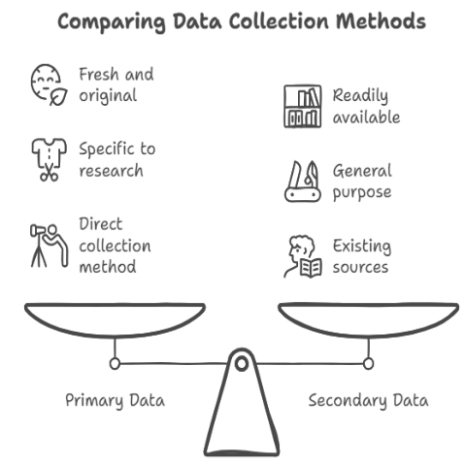
- Primary Data: Primary data refers to original data collected by the researcher specifically for the current research project. This data is fresh, collected for the first time, and directly addresses the specific research questions.
  - Examples: Responses from surveys or questionnaires conducted by the researcher, results from experiments, observations recorded directly by the researcher, data from focus groups.
- Secondary Data: Secondary data refers to data that has already been collected by someone else for a purpose other than the current research. It is readily available and typically comes from existing sources.
  - Examples: Government publications (census data, economic reports), academic journals, company reports, historical documents, existing databases, internet sources.

B. SAMPLING
1. DEFINITION AND PURPOSE
Sampling is the process of selecting a subset (a sample) from a larger group (a population) to study. The goal is to gather information about the sample that can be generalized to the entire population.
The primary purpose of sampling is:
- To make inferences about the characteristics of a population based on the data collected from a sample.
- To gain insights into patterns, trends, and relationships within a population.
- To test hypotheses and answer research questions efficiently.
Definition:
According to Gerald Hursh “a Sample Design is the theoretical basis and the practical means by which we infer the characteristics of some population by generalizing from the characteristics of relatively few of the units comprising the population”. According to Rosander, “The sample has many advantages over a census or complete enumeration. If carefully designed, the sample is not only considerably cheaper but may give results which are just accurate and sometimes more accurate than those of a census. Hence a carefully designed sample may actually be better than a poorly planned and executed census.”
2. POPULATION, SAMPLE
- Population: The population (or target population) refers to the entire group of individuals, objects, or events that are of interest to the researcher. It is the complete set of elements that share a common characteristic and to which the results of the study are intended to be generalized.
  - Example: All registered voters in a country, all customers of a particular company, or all products manufactured in a factory.
- Sample: A sample is a subset of the population that is selected for study. It is a smaller group that is intended to represent the larger population. The characteristics of the sample are then studied to make generalizations or inferences about the population from which it was drawn.
  - Example: A group of 500 registered voters selected from the entire voter population, or 100 customers surveyed from a company's customer base.
- Why is Sampling Needed? (Importance & Uses): Sampling is crucial in research due to several practical and methodological reasons:
  - Practicality: It's often impossible or too costly to study every individual in a large or geographically dispersed population.
  - Efficiency & Time-saving: Sampling allows for faster data collection and analysis, speeding up the research process significantly.
  - Cost-effectiveness: It reduces the financial and human resources required for research.
  - Accuracy: A well-designed and carefully executed sample can sometimes yield more accurate results than a poorly designed census, especially due to fewer non-sampling errors (e.g., better training of fewer data collectors).
  - Destructive Testing: Some testing methods destroy the object being tested (e.g., quality control of light bulbs). In such cases, sampling is essential, as testing the entire population would mean destroying all items.
  - Generalizability: When you need to make inferences and generalizations about a larger population, sampling provides the framework.
- Errors in Sampling:
  - Sampling Error: This is the natural discrepancy or variation that arises simply because a sample is a subset of the population and may not perfectly represent the population. It's inherent in any sampling process (unless a census is conducted) and is quantifiable. It generally decreases as sample size increases.
  - Non-Sampling Error: These are errors that occur during data collection, processing, or analysis that are not related to the sampling process itself. They can occur in both samples and censuses.
    - Examples: Measurement error (poorly designed questions, faulty instruments), non-response bias (certain groups less likely to respond), processing errors, interviewer bias, reporting errors.
A Sample design is a definite plan for obtaining a sample from a given population.

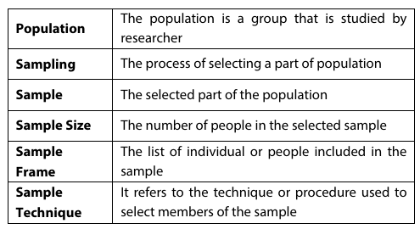

Merits of Sampling (Why Sampling is Needed/Its Importance)
- Practicality: Often impossible or too costly to study every individual in a large population.
- Efficiency & Time-saving: Allows for faster data collection and analysis.
- Cost-effectiveness: Reduces financial and human resources required for research.
- Accuracy: Well-designed and carefully executed samples can sometimes yield more accurate results than poorly designed censuses, especially due to fewer non-sampling errors.
- Destructive Testing: Essential when the measurement process destroys the object being tested (e.g., quality control).
- Generalizability: Provides the framework for making inferences and generalizations about a larger population.
3. SAMPLING FRAME
- Definition: A sampling frame is a list of all the elements in the population from which the sample will be drawn. It provides a complete and accurate representation of the population and serves as the operational definition of the population for the study.
- Importance:
  - It ensures that every element in the population has a chance of being selected for the sample, which is fundamental for probability sampling.
  - It helps to reduce bias and improve the representativeness of the sample.
  - If the sampling frame is incomplete or inaccurate, the sample may not be truly representative of the population, leading to biased results.
- Examples:
  - A telephone directory.
  - A customer database.
  - A list of registered voters.
  - A membership list of an organization.
- Challenges:
  - Creating a complete and accurate sampling frame can be difficult, especially for large or diverse populations.
  - Sampling frames may become outdated or incomplete over time (e.g., new residents, changes in contact information).
  - Some populations may not have readily available sampling frames (e.g., homeless individuals).

4. SAMPLING DESIGN: THE BLUEPRINT FOR SELECTION
Sampling design is the blueprint for how you'll select participants or data points from a larger population to represent that population in your research. A well-designed sample ensures that your findings are generalizable and reliable.
ESSENTIALS: Points to be Considered in Sampling Design
- Define the Population: Clearly identify the entire group of interest you want to study.
- Determine the Sampling Frame: Create or obtain a list of all elements in the population from which the sample will be drawn.
- Select a Sampling Method: Choose between probability (random selection) and non-probability (non-random selection) sampling based on research objectives and population characteristics.
- Plan Procedure for Selecting Sampling Units: Detail the specific steps and mechanics for selecting individuals or units according to the chosen method.
- Determine Sample Size: Calculate the appropriate number of participants needed to achieve desired precision and confidence levels.
- Implement the Sampling Plan: Execute the chosen method carefully and consistently to select the actual sample.
- Assess Sample Representativeness: Evaluate how well the selected sample reflects the characteristics of the overall population.
STEPS IN SAMPLING DESIGN
- Define the target population.
  - Explanation: Clearly identify the entire group of individuals, objects, or events you want to study and to which your research findings will apply. This group should share specific characteristics relevant to your research.
  - Short Example: You want to study the reading habits of undergraduate students in India. Your target population is "All undergraduate students currently enrolled in universities in India."
- Determine the sampling frame.
  - Explanation: Create or obtain a list of all the individual units within your defined target population from which you will actually draw your sample. This list acts as the operational definition of your population.
  - Short Example: Since getting a list of all Indian undergraduate students is impossible, you might use a list of students from 10 major universities across India that you have access to. This list becomes your sampling frame. (Note: This acknowledges an imperfect frame, which is common in real research).
- Decide between probability or non-probability sampling.
  - Explanation: Choose the overarching approach for selecting your sample.
    - Probability sampling: Each member of the population has a known, non-zero chance of being selected (e.g., random selection). Used when generalizability to the population is key.
    - Non-probability sampling: Selection is based on convenience or the researcher's judgment. Used when probability sampling isn't feasible or for exploratory research.
  - Short Example: You want to generalize your findings to all Indian undergraduate students, so you decide on probability sampling (specifically, a multi-stage approach).
- Plan the procedure for selecting sampling units.
  - Explanation: Detail the specific step-by-step method you will use to select participants according to your chosen sampling type. This is the "how-to" guide for selection.
  - Short Example: You choose a stratified random sampling method. You decide to stratify by university size (large, medium, small) and region (North, South, East, West) within your sampling frame. From each stratum, you will then randomly select a proportional number of students.
- Determine the sample size.
  - Explanation: Calculate the precise number of participants or units needed for your study. This calculation considers factors like the desired confidence level, margin of error, and variability within the population, ensuring your results are statistically sound.
  - Short Example: Based on your desired confidence level (95%) and acceptable margin of error ( ± 3%), you use a sample size formula and determine you need to survey 2,000 undergraduate students.
- Select the actual sampling units.
  - Explanation: Execute the plan from step 4 and literally pick out the specific individuals or elements that will be part of your sample based on your determined sample size.
  - Short Example: You use random number generators for each stratum to select the specific 2,000 student IDs from your compiled university lists.
- Conduct fieldwork.
  - Explanation: This is the final stage of the sampling design process, where you physically go out and collect the data from the selected sample using your chosen data collection methods (e.g., distribute questionnaires, conduct interviews).
  - Short Example: You send out the online questionnaires to the 2,000 selected students and collect their responses over a two-week period.

5. TYPES OF SAMPLING TECHNIQUES
Sampling techniques are broadly categorized into probability and non-probability methods.
a. Probability Sampling:
In probability sampling, every element in the population has a known and non-zero chance of being selected. This method ensures that the sample is representative of the population, allowing for generalization of findings and statistical inference.
- Simple Random Sampling:
  - Every possible sample of a given size has an equal chance of being selected, and every element in the population has an equal chance of being included in the sample.
  - Method: Assign a unique number to each element in the sampling frame. Use a random number generator or lottery method to select participants.
  - Use: When the population is relatively homogeneous and a complete sampling frame is available.
  - Example: Drawing names from a hat, or using a computer to randomly select 100 student IDs from a university's full roster.
- Systematic Sampling:
  - Elements are selected from the sampling frame at regular intervals after a random starting point.
  - Method: Determine a sampling interval (k) by dividing the population size (N) by the desired sample size (n) (k=N/n). Choose a random starting point between 1 and k. Select every kth element thereafter.
  - Use: When a complete and ordered sampling frame is available and time-efficiency is a concern.
  - Example: Selecting every 10th customer entering a store, starting with a randomly chosen customer between 1 and 10.
- Stratified Sampling:
  - The population is divided into homogeneous subgroups (strata) based on relevant characteristics (e.g., age, gender, income level). Then, a simple random sample is drawn from each stratum. This ensures representation from all key subgroups.
  - Method: Divide population into strata. Calculate proportion of each stratum in the population. Draw a simple random sample from each stratum proportionate to its size in the population.
  - Use: When the population is heterogeneous and the researcher wants to ensure representation of specific subgroups.
  - Example: Dividing a student population into strata by academic year (freshman, sophomore, junior, senior) and then randomly sampling a proportional number of students from each year.
- Cluster Sampling:
  - The population is divided into naturally occurring groups or clusters (e.g., geographic areas, schools, hospitals). A random sample of clusters is then selected, and all individuals within the chosen clusters are included in the sample. Can be single-stage (all in selected clusters) or multi-stage (sampling within selected clusters).
  - Method: Divide population into clusters. Randomly select a certain number of clusters. Collect data from all units within the selected clusters (or randomly sample within selected clusters for multi-stage).
  - Use: When a complete list of individuals is not available, or when the population is geographically dispersed, making other methods impractical.
  - Example: To study high school students in a large city, randomly select 10 high schools (clusters) and then survey all students within those 10 schools.
b. Non-Probability Sampling:
In non-probability sampling, elements are selected based on the researcher's subjective judgment or convenience, not on random chance. This means that not every element has a known chance of being selected, and thus, findings cannot be statistically generalized to the larger population. It is often used in exploratory research, qualitative studies, or when probability sampling is not feasible.
- Convenience Sampling:
  - Participants are selected based on their easy accessibility and proximity to the researcher.
  - Method: Recruiting participants who are readily available.
  - Use: Quick and inexpensive, often used in pilot studies or preliminary research.
  - Example: Surveying students in a classroom, interviewing people encountered at a shopping mall.
- Purposive (Judgmental) Sampling:
  - Participants are deliberately selected based on the researcher's judgment about who would be most appropriate for the study, often because they possess specific characteristics or expertise.
  - Method: Researcher identifies specific criteria and intentionally selects individuals who meet those criteria.
  - Use: When specific expertise or characteristics are needed, common in qualitative research.
  - Example: Interviewing expert doctors about a specific rare disease, selecting opinion leaders for a political survey.
- Quota Sampling:
  - Similar to stratified sampling, the population is divided into subgroups, but participants are then selected non-randomly from each subgroup until a predetermined quota for each subgroup is met.
  - Method: Identify population characteristics and their proportions. Set quotas for each category. Recruit participants non-randomly until quotas are filled.
  - Use: When aiming for a certain representation of subgroups without the cost or time of random selection. Often used in market research.
  - Example: Interviewing 50 male and 50 female shoppers at a mall, ensuring a specific age distribution within each gender, but selecting them based on convenience until the numbers are met.
- Snowball Sampling:
  - Initial participants are selected, and then they are asked to identify and recruit other potential participants who fit the study's criteria, often used for hard-to-reach populations.
  - Method: Start with a few initial participants who meet the criteria. Ask them to refer others who also meet the criteria.
  - Use: Ideal for hidden populations, sensitive topics, or communities where trust is crucial.
  - Example: Studying drug users, homeless individuals, or members of a clandestine organization, where initial contacts lead to further participants.

6. DETERMINING THE APPROPRIATE SAMPLE SIZE
Determining the appropriate sample size is crucial for any research study. It ensures that the results obtained are statistically significant and representative of the population being studied.
Factors Affecting Sample Size:
- Population Size:
  - The total number of individuals in the group you want to study.
  - For smaller populations, the sample size will be a larger proportion of the total population (often a correction factor is applied).
  - For very large populations, the actual size of the population has less of an effect on the required sample size, as the "law of large numbers" comes into play.
- Confidence Level:
  - The degree of certainty that the sample results accurately reflect the population.
  - Common confidence levels are 90%, 95%, and 99%.
  - A higher confidence level (e.g., 99%) increases the certainty that the results are accurate, but it also requires a larger sample size.
- Margin of Error (Confidence Interval):
  - The allowable difference between the sample results and the true population value. It defines the range within which the true population parameter is expected to fall.
  - A smaller margin of error (e.g., $\pm$1%) provides greater precision, but it also requires a larger sample size.
  - Conversely, a larger margin of error will allow for a smaller sample size.
- Standard Deviation (Variability):
  - The amount of variation or dispersion in the population regarding the characteristic being measured.
  - A higher standard deviation (more variability) requires a larger sample size to adequately capture that variation.
- Desired Power of the Test:
  - This is generally used when hypothesis testing. Power is the probability that the test will reject a false null hypothesis. Higher power means a greater chance of finding a true effect if one exists. Achieving higher power typically requires a larger sample size.
- Type of Study:
  - The specific type of research being conducted (e.g., survey, experiment, qualitative study) can influence the sample size requirements. For instance, qualitative studies often use smaller, purposively selected samples.
METHODS FOR CALCULATING SAMPLE SIZE:
- Formulas:
  - There are various formulas for calculating sample size, depending on the type of data (e.g., proportions vs. means) and the desired level of precision.
  - A common formula for estimating sample size for proportions is:
n=[Z²⋅p⋅(1−p)]​/e²
Where:
    - n = sample size
    - Z = Z-score corresponding to the desired confidence level (e.g., 1.96 for 95% confidence)
    - p = estimated population proportion (often 0.5 is used for maximum sample size if unknown)
    - e = margin of error
  - For continuous data, where you are dealing with means, the formula will include the population standard deviation (σ).
- Tables:
  - Sample size tables provide pre-calculated sample sizes for various combinations of confidence levels, margins of error, and estimated population proportions.
- Online Calculators:
  - Many online tools can calculate sample size automatically, simplifying the process for researchers.
Impact of Confidence Levels and Margin of Error:
- Confidence Level: A higher confidence level (e.g., 99%) increases the certainty that the sample results reflect the true population parameter, but it requires a larger sample size.
- Margin of Error: A smaller margin of error provides greater precision in your estimate, but it also requires a larger sample size. Conversely, a larger margin of error will allow for a smaller sample size.
There is an inverse relationship between sample size and the margin of error, and a direct relationship between sample size and the confidence level. It's important to choose a sample size that balances the desired level of precision with the available resources.

C. SURVEYS
A survey is a research method used for collecting data from a predetermined group of respondents to gain information and insights into various topics of interest. It is a highly versatile and widely used method, particularly for gathering information about attitudes, opinions, behaviors, and characteristics of a large population.
1. Types of Surveys:
- Questionnaires: A set of written questions or prompts used to gather information from respondents. They can be administered in various formats:
  - Paper-and-Pencil Surveys: Traditional method, often distributed in person or by mail.
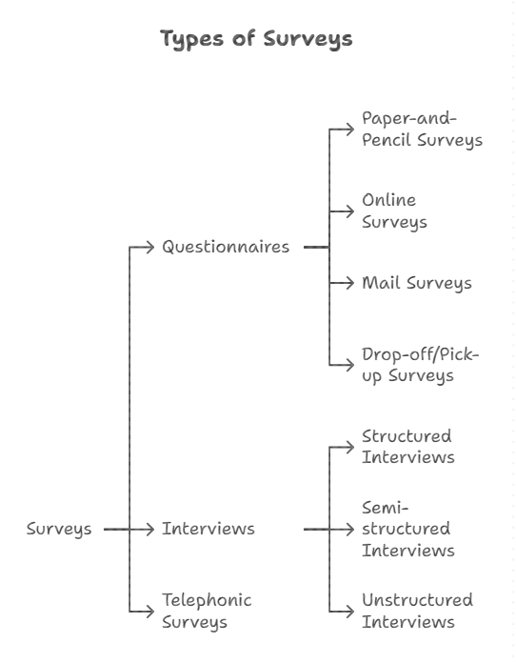
  - Online Surveys: Administered via the internet using platforms like Google Forms, SurveyMonkey, Qualtrics. Highly efficient for reaching large audiences.
  - Mail Surveys: Questionnaires sent through postal mail, often with a return envelope.
  - Drop-off/Pick-up Surveys: Questionnaires left at a location for respondents to complete and then retrieved.
- Interviews: Direct, typically face-to-face or virtual, interaction between an interviewer and a respondent to gather information.
  - Structured Interviews: Follow a rigid set of pre-determined questions, similar to a verbal questionnaire.
  - Semi-structured Interviews: Have a set of core questions but allow for flexibility, probing, and follow-up questions.
  - Unstructured Interviews: Highly flexible, open-ended, more conversational, used to explore topics in depth.
- Telephonic Surveys: Data collected over the phone, where interviewers ask questions and record responses.
2. Advantages of Surveys:
- Cost-Effective: Especially online surveys, they can be a relatively inexpensive way to gather data from a large number of people.
- Time-Efficient: Data can be collected quickly from a broad geographical area.
- Versatility: Can be used to collect various types of information (demographics, attitudes, behaviors, opinions).
- Standardization: Structured surveys ensure consistency in questions and response options, making data analysis easier.
- Anonymity/Confidentiality: Can provide a sense of anonymity (especially online or mail surveys), which may encourage more honest responses on sensitive topics.
- Generalizability (with good sampling): If a probability sampling method is used, survey results can be generalized to the larger population.
3. Disadvantages of Surveys:
- Response Bias:
  - Social Desirability Bias: Respondents may provide answers they believe are socially acceptable rather than their true opinions.
  - Acquiescence Bias: Tendency to agree with statements regardless of content.
  - Extreme Response Bias: Tendency to use extreme ends of a rating scale.
- Low Response Rates: Especially with unsolicited mail or online surveys, getting sufficient participation can be challenging, leading to non-response bias.
- Lack of Depth: Structured surveys may not allow for in-depth exploration of complex issues or unexpected responses.
- Wording Effects: Poorly worded or ambiguous questions can lead to misinterpretation and inaccurate data.
- Interviewer Bias (in interviews): The interviewer's tone, appearance, or reactions can unintentionally influence respondent answers.
- Inability to Establish Causation: Surveys typically measure correlation, not causation, as researchers do not manipulate variables or control for all extraneous factors.

IV. BASICS OF DATA ANALYSIS: NUMERICAL AND GRAPHICAL ANALYSIS
A. INTRODUCTION TO DATA ANALYSIS
Data analysis is the process of inspecting, cleaning, transforming, and modeling data with the goal of discovering useful information, informing conclusions, and supporting decision-making. It is a critical step in the research process, allowing researchers to make sense of the raw data collected and to test their hypotheses. Effective data analysis ensures that the conclusions drawn from the research are valid and reliable. It often involves both numerical (statistical) and graphical (visualization) approaches.
B. Numerical Analysis (Descriptive Statistics)
Numerical analysis, often involving descriptive statistics, provides quantitative summaries of data. It helps in describing the basic features of the data in a study.
1. Measures of Central Tendency:
These statistics represent the "center" or typical value of a dataset.
- Mean:
  - The arithmetic average of a dataset. It is calculated by summing all values and dividing by the number of values.
  - Use: Most commonly used measure when data is symmetrically distributed without extreme outliers.
  - Formula: xˉ=n∑xi​​ (for a sample) or μ=N∑xi​​ (for a population)
  - Example: For scores (5, 7, 8, 10, 10), Mean = (5+7+8+10+10)/5=40/5=8.
- Median:
  - The middle value in a dataset when the values are arranged in ascending or descending order. If there's an even number of values, it's the average of the two middle values.
  - Use: Preferred when the data is skewed or contains outliers, as it is not affected by extreme values.
  - Example: For scores (5, 7, 8, 10, 10), Median = 8. For (5, 7, 8, 9, 10, 12), Median = (8+9)/2=8.5.
- Mode:
  - The value that appears most frequently in a dataset. A dataset can have one mode (unimodal), multiple modes (multimodal), or no mode.
  - Use: Useful for categorical or nominal data, or to identify the most common occurrence in any type of data.
  - Example: For scores (5, 7, 8, 10, 10), Mode = 10.
2. Measures of Dispersion:
These statistics describe the spread or variability of data points around the central tendency.
- Range:
  - The difference between the highest and lowest values in a dataset.
  - Use: A simple and quick measure of spread, but heavily influenced by outliers.
  - Formula: Range = Maximum value - Minimum value
  - Example: For scores (5, 7, 8, 10, 10), Range = 10 - 5 = 5.
- Variance:
  - The average of the squared differences from the mean. It quantifies the extent to which individual data points deviate from the mean. A higher variance indicates greater spread.
  - Use: A fundamental measure in many statistical tests.
  - Formula (Sample Variance): s2=n−1∑(xi​−xˉ)2​
  - Example: Calculating variance is more complex but it would show the overall spread. If data points are clustered close to the mean, variance is small. If widely spread, variance is large.
- Standard Deviation:
  - The square root of the variance. It is the most commonly used measure of dispersion because it is in the same units as the original data, making it easier to interpret than variance.
  - Use: Provides a clear indication of the typical distance between data points and the mean. Used widely in inferential statistics.
  - Formula (Sample Standard Deviation): s=∑(xi​−xˉ)²/n−1​​
  - Example: If the standard deviation of test scores is 2, it means scores typically vary by about 2 points from the average.
3. Frequencies and Percentages:
- Frequencies:
  - A count of how many times each value or category appears in a dataset. Often presented in frequency tables.
  - Use: To understand the distribution of categorical data or the raw counts of specific occurrences.
  - Example: In a survey, 20 respondents chose "Agree," 15 chose "Neutral," and 10 chose "Disagree."
- Percentages:
  - The proportion of a frequency out of the total, expressed as a hundredth.
  - Use: To compare proportions across different categories or groups, providing a standardized view of distribution.
  - Formula: Percentage = (Frequency / Total N) × 100
  - Example: For the survey example, "Agree" = (20/45)×100≈44.4%.
C. Graphical Analysis (Data Visualization)
Graphical analysis involves creating visual representations of data to identify patterns, trends, relationships, and outliers. It makes complex data more accessible and easier to understand.
1. Types of Graphs:
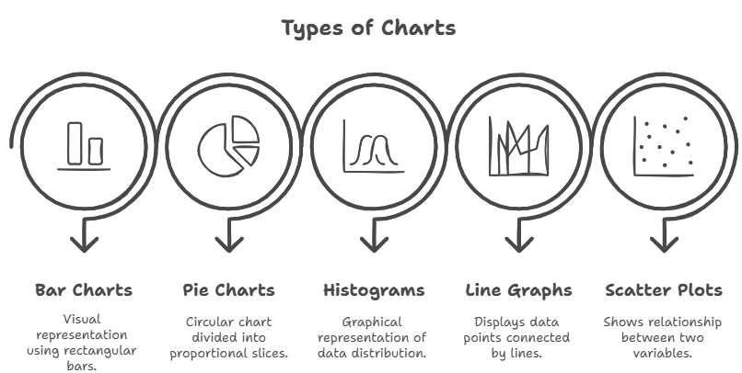
- Bar Charts:
  - Description: Use rectangular bars of varying heights or lengths to represent different categories. The length of each bar is proportional to the value it represents.
  - Use: Ideal for comparing discrete categories or illustrating changes over time for a limited number of categories.
  - Example: Number of students in different academic majors, sales figures per quarter.
- Pie Charts:
  - Description: A circular chart divided into sectors, where each sector represents a proportion of the whole. The arc length of each sector is proportional to the quantity it represents.
  - Use: Best for showing parts of a whole (proportions or percentages) for a small number of categories. Should sum to 100%.
  - Example: Market share of different companies, breakdown of a budget.
- Histograms:
  - Description: Similar to bar charts, but used for continuous data. The bars touch, representing intervals or bins of numerical data. The height of the bar indicates the frequency of data points falling within that interval.
  - Use: To display the distribution of a single continuous variable, showing its shape, spread, and central tendency.
  - Example: Distribution of student test scores, frequency of heights in a population.
- Line Graphs:
  - Description: Use points connected by lines to show trends or changes over a continuous period or sequence. The x-axis usually represents time or an ordered sequence, and the y-axis represents the variable being measured.
  - Use: Excellent for showing trends over time, comparing multiple series over time, or illustrating functional relationships.
  - Example: Stock prices over a year, temperature changes throughout a day, population growth over decades.
- Scatter Plots:
  - Description: Use individual data points to plot the values of two different numerical variables (one on the x-axis, one on the y-axis).
  - Use: To visualize the relationship or correlation between two continuous variables. The pattern of the points reveals the strength and direction of the relationship (positive, negative, no correlation).
  - Example: Relationship between study hours and exam scores, height vs. weight.
2. Choosing Appropriate Graphs for Different Data Types:
The choice of graph largely depends on the type of data you have and what you want to communicate:
- Categorical Data (Nominal/Ordinal):
  - Bar Charts: For comparing frequencies or amounts across distinct categories.
  - Pie Charts: For showing proportions of a whole (best for 2-5 categories).
- Numerical Data (Interval/Ratio):
  - Histograms: For showing the distribution of a single continuous variable.
  - Line Graphs: For showing trends over time or ordered sequences.
  - Scatter Plots: For showing the relationship between two continuous variables.
- Comparison of Groups:
  - Bar Charts: For comparing means or totals of different groups.
  - Box Plots: (often included in more advanced analysis) for comparing distributions across groups.
3. Importance of Clear and Accurate Labeling:
Clear and accurate labeling is paramount for any graph to be understandable and credible. Essential labeling includes:
- Title: A concise and informative title that describes what the graph represents.
- Axis Labels: Clearly label both the x-axis and y-axis, including units of measurement where applicable.
- Legend/Key: If the graph contains multiple data series or categories, a legend is needed to distinguish them.
- Source: If the data comes from an external source, cite it.
- Data Labels (optional): Sometimes, directly labeling data points or bar values can enhance clarity, especially for key figures.
- Scales: Ensure scales are appropriate and start from zero (unless a break is clearly indicated) to avoid misrepresenting data.

V. INTRODUCTION TO INFERENTIAL STATISTICS
A. PURPOSE OF INFERENTIAL STATISTICS
Inferential statistics is a branch of statistics that allows researchers to make generalizations, predictions, and draw conclusions about a population based on data collected from a sample of that population. Unlike descriptive statistics, which merely summarizes and describes the characteristics of a dataset, inferential statistics aims to infer properties of a larger group.
DEFINITION (CRESWELL & CRESWELL, 2018)
• Inferential statistics are techniques that allow researchers to draw conclusions or make predictions about a population based on a sample of data.
• Moves beyond describing what is observed (descriptive) to making generalizations (inferences) about the larger group
THE PRIMARY PURPOSES of inferential statistics are:
- Making inferences about a population based on a sample: Since it's often impractical or impossible to collect data from every member of a population, researchers study a representative sample. Inferential statistics provides the tools to use the sample data to estimate population parameters (like the population mean or proportion) and to determine how likely it is that the sample results reflect the true state of the population. For instance, if a sample of 100 students shows an average test score of 80, inferential statistics helps determine if we can conclude that the average score for all students in the university is around 80.
- Testing hypotheses: Inferential statistics is central to the scientific method, enabling researchers to formally test their hypotheses (e.g., that a new drug has an effect, that two groups differ significantly, or that there's a relationship between two variables). It provides a framework to determine whether observed effects or relationships in a sample are statistically significant, meaning they are unlikely to have occurred by random chance, and thus can be generalized to the population.
B. Key Concepts
Understanding these core concepts is fundamental to interpreting the results of inferential statistical analyses:
- Population and Sample
Population: The complete group about which the researcher wants to draw conclusions.
Sample: A subset of the population used for analysis.
- Estimation and Confidence Intervals
Estimation: Using sample statistics (e.g., sample mean) to estimate population parameters.
Confidence Interval: A range of values, derived from the sample, that likely contains the population parameter with a certain level of confidence (e.g., 95%).
- Hypothesis Testing
Null Hypothesis (H₀): States that there is no effect or relationship between variables.
Alternative Hypothesis (H₁): States that there is an effect or relationship.
Significance Level (α): Commonly set at 0.05; the probability of rejecting the null hypothesis when it is actually true (Type I error).
- Statistical Tests (as per data type and design)
t-test: Compares means between two groups.
ANOVA (Analysis of Variance): Compares means among three or more groups.
Chi-Square Test: Examines relationships between categorical variables.
Correlation: Measures strength and direction of relationship between two continuous variables.
Regression: Examines the predictive relationship between variables.
- p-value
The probability of observing the data (or something more extreme) if the null hypothesis is true.
If p < α (commonly 0.05), the null hypothesis is rejected.
- General Process
- State research hypothesis.
- Select appropriate statistical test based on data and hypothesis.
- Calculate test statistic and p-value.
- Compare p-value to significance level.
- Draw a conclusion (accept or reject null hypothesis).
- Report findings and interpret in context.
- p-value: The p-value (probability value) is a measure of the evidence against the null hypothesis. It represents the probability of obtaining the observed results (or more extreme results) from your sample, assuming that the null hypothesis is true.
  - Interpretation:
    - A small p-value (typically ≤ 0.05) indicates strong evidence against the null hypothesis, suggesting that the observed result is unlikely to have occurred by chance alone. This leads to the rejection of the null hypothesis in favor of the alternative hypothesis.
    - A large p-value (typically > 0.05) indicates weak evidence against the null hypothesis, suggesting that the observed result could plausibly have occurred by chance. This leads to failing to reject the null hypothesis. It does not mean the null hypothesis is true, but rather that there's not enough evidence to reject it.
- Significance Level (α): The significance level (alpha, α) is a pre-determined threshold that a researcher sets before conducting the study. It represents the maximum probability of making a Type I error (incorrectly rejecting a true null hypothesis).
  - Common Values: The most commonly used significance level in social sciences and many other fields is α=0.05 (or 5%). Other common values are 0.01 (1%) or 0.10 (10%).
  - Decision Rule: If the calculated p-value is less than or equal to the chosen significance level (p-value≤α), the null hypothesis is rejected. If the p-value is greater than α (p-value>α), the null hypothesis is not rejected.
- Confidence Intervals: A confidence interval (CI) is a range of values that is likely to contain the true population parameter (e.g., population mean, population proportion) with a certain level of confidence. It provides a more informative estimate than a single point estimate (like a sample mean) because it conveys the precision and uncertainty of the estimate.
  - Interpretation: A 95% confidence interval for a mean, for example, means that if you were to repeat the sampling process many times, 95% of the confidence intervals constructed would contain the true population mean.
  - Use: Confidence intervals complement hypothesis testing. If the confidence interval for the difference between two means (or proportions) includes zero, it suggests there is no statistically significant difference. If it does not include zero, it indicates a significant difference.
C. COMMON STATISTICAL TESTS (WHEN TO USE)
These are some of the most frequently used inferential statistical tests:
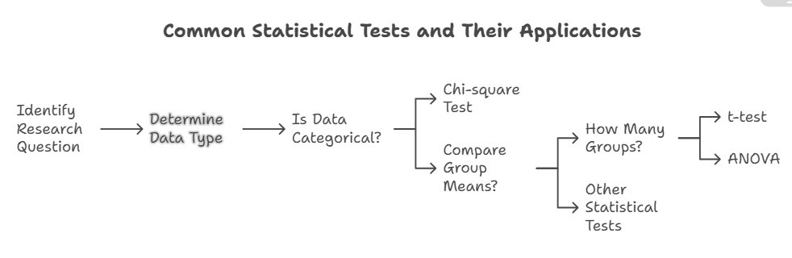
- t-tests:
  - When to use: Used to compare the means of two groups.
    - Independent samples t-test: To compare the means of two independent groups (e.g., average test scores of a treatment group vs. a control group).
    - Paired samples t-test: To compare the means of two related groups or measurements taken from the same individuals at two different times (e.g., pre-test vs. post-test scores for the same participants).
    - One-sample t-test: To compare the mean of a single sample to a known or hypothesized population mean.
- ANOVA (Analysis of Variance):
  - When to use: Used to compare the means of three or more groups. It tests whether there is a statistically significant difference between the means of these groups.
    - One-way ANOVA: Used when comparing the means of groups based on one independent categorical variable (e.g., comparing test scores across three different teaching methods).
    - Two-way ANOVA: Used when comparing means based on two independent categorical variables and their interaction (e.g., comparing test scores based on teaching method AND gender).
- Chi-square (χ2) test:
  - When to use: Used to analyze categorical data (frequencies or counts).
    - Chi-square Test of Independence: To determine if there is a statistically significant association or relationship between two categorical variables (e.g., Is there a relationship between gender and preferred political candidate?).
    - Chi-square Goodness-of-Fit Test: To determine if the observed frequencies of a single categorical variable differ significantly from expected frequencies (e.g., Does the observed distribution of coin flips match the expected 50/50 distribution?).

Statistical Distributions
DISTRIBUTION | DESCRIPTION | WHEN TO USE
Normal (Z) | Symmetrical bell-shaped distribution. Defined by mean (μ) and standard deviation (σ). Used when population parameters are known or for large samples (due to CLT). | Hypothesis testing when σ is known or sample size (n) is large (typically n≥30).
t-distribution | Symmetrical, bell-shaped, but with fatter tails than the normal distribution, accounting for greater uncertainty with smaller sample sizes. It approaches the normal distribution as the degrees of freedom (df) increase. | Hypothesis testing when σ is unknown and sample size (n) is small (typically n<30). Used for t-tests and constructing confidence intervals for means with unknown population standard deviation.
Chi-Square (χ2) | A positively skewed distribution, used primarily for categorical data. It's related to the sum of squared standard normal variables. | Categorical data analysis: Testing for independence between two categorical variables (χ2 Test of Independence) or testing if observed frequencies match expected frequencies (χ2 Goodness-of-Fit Test). Also used for confidence intervals for population variance.
F-distribution | A positively skewed distribution that arises in the context of comparing variances. It's the ratio of two independent chi-square variables divided by their respective degrees of freedom. | Comparing variances of two or more populations (e.g., in ANOVA to compare means of three or more groups, where it tests the ratio of between-group variance to within-group variance). Used for ANOVA and testing the equality of variances (F-test for equality of variances).
Export to Sheets

Steps in Hypothesis Testing
STEP | ACTION | EXPLANATION
1 | Formulate Hypotheses | Define the null hypothesis (H0​) (the status quo) and the alternative hypothesis (Ha​) (what you want to prove).
2 | Set Significance Level (α) | Choose the probability of making a Type I error (rejecting H0​ when it's true), commonly 0.05.
3 | Choose the Test Statistic | Select the appropriate test (Z, t, χ2, F, etc.) based on data type, research question, and assumptions.
4 | Calculate Test Statistic and P-value | Compute the test statistic from your sample data. Use this to find the p-value, which is the probability of observing such data if H0​ were true.
5 | Make a Decision | Compare p-value to α: If p-value <α, reject H0​. Otherwise, fail to reject H0​. Alternatively, compare the test statistic to critical values.
6 | State the Conclusion | Interpret your decision in the context of the original research question, clearly stating whether there is sufficient evidence to support Ha​.

